FSD for Tia & Noordin Mobile App

Phase 1 – LOAN, Delta Change from SPA

8/18/2015

Abeo International Pte Ltd

Yinhui

Version 2.0

## Objective of Mobile App

        The main objectives of the mobile apps are as follows:

1. For the IC to operate completely on the tablets and NOT access SAP
2. To mask the entire ERPs from rivals with Mobile apps as front
3. Easy of usage
4. Impress clients with the efficiency of handling cases.
5. exercise control over IC
6. provide easy access for managers and lawyers to oversee the entire operation

## Expected Authorized Scope of Users of Mobile App

* Lawyers and managers see all of the case details and listing
* IC see partial and limited to their own cases handled

## Login Screen

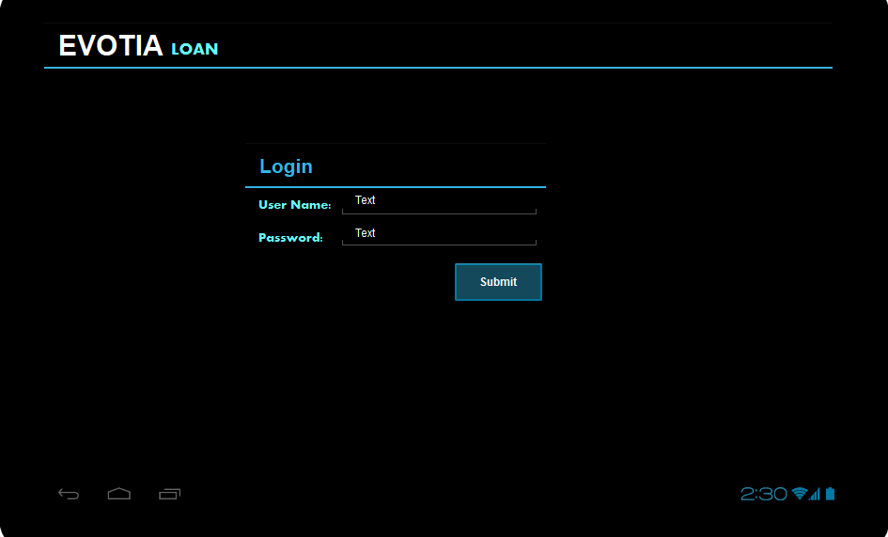

1. Enter User Name and Password. Click Submit to Login.
2. After login, direct to Dashboard.

# Dashboard

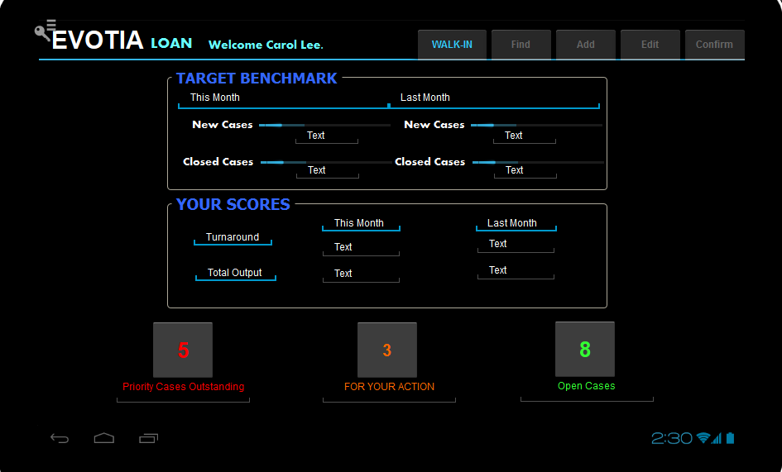

Logic remains the same as with SPA. The cases refer to Loan type cases. Benchmark are Loan Case benchmarks.

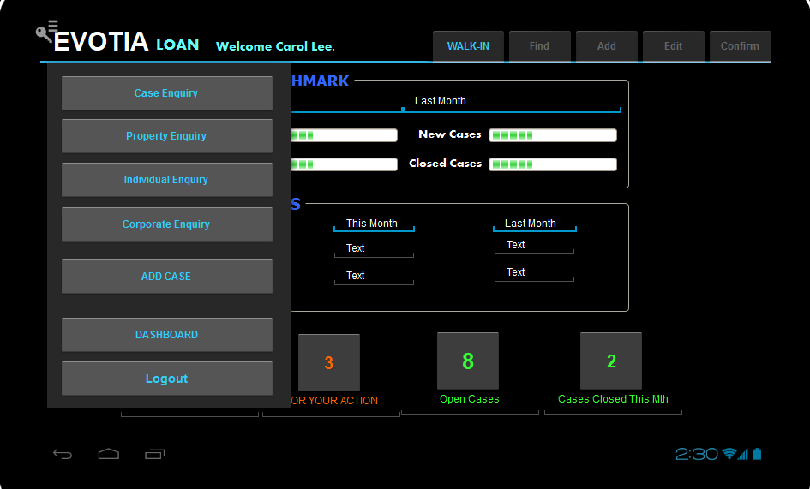

# WALK-IN

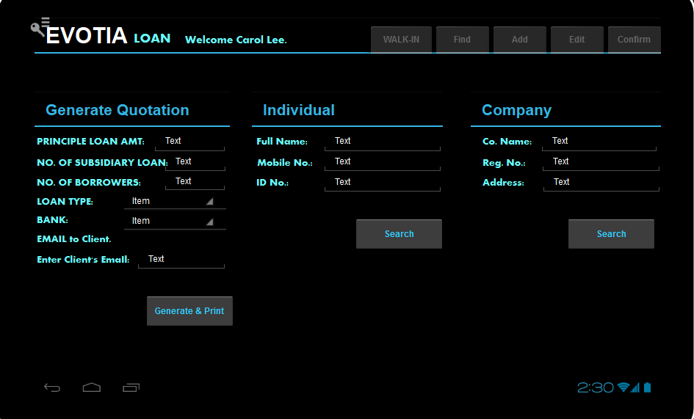

“Bank name” lists names of 5 banks.

# List of Loans

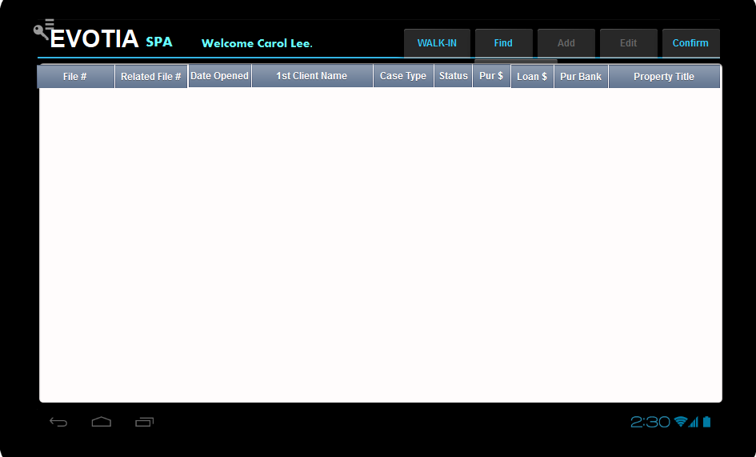

Change the list of cases to the following table.

|  |  |  |  |  |  |  |  |  |  |  |  |  |
| --- | --- | --- | --- | --- | --- | --- | --- | --- | --- | --- | --- | --- |
| CaseFile No. | Related File No. | Branch Code | File Opened Date | IC | Case Type | 1st Client Name | Bank | Lot/PTD/PT No. | Case Amount | User Code | Status | File Closed Date |
|  |  |  |  |  | *5 types |  |  |  |  | *6 user codes | Open/Closed/Cancelled |  |

# Screens for the Process of Adding a New Loan Case

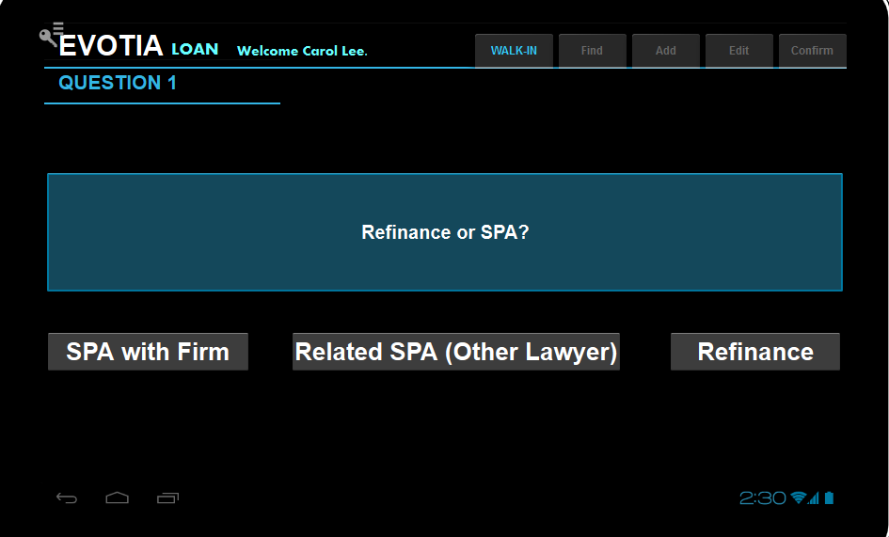

When user click “Add Case”, bring them to Question 1.

If user click “SPA with Firm”, update CASE_LOANTYPE =”SPALOAN”. Proceed to Question 2.

If user click “Related SPA (Other Lawyer)”, update CASE_LOANTYPE =”SPALOAN”. Proceed to Question 3.

If user click “Refinance”, update CASE_LOANTYPE=”REFINANCE”. Proceed to “Create Case”.

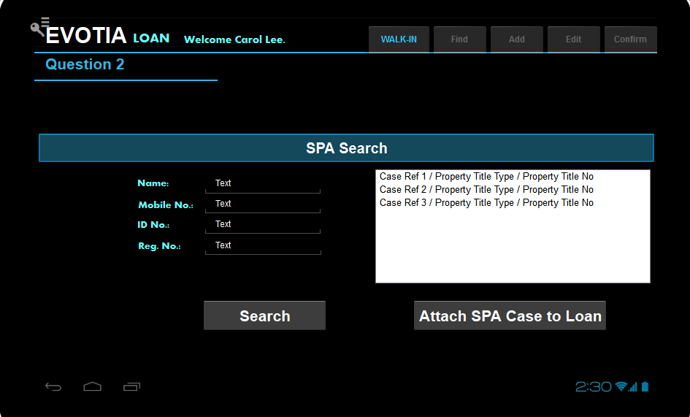

User enters some customer details and click Search.

User chooses a case and click “Attach SPA Case to Loan”.

Proceed to Add Case.

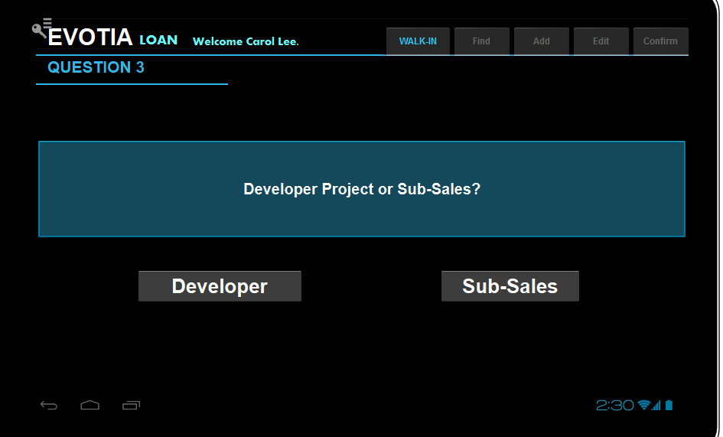

DEVELOPER PROJECT CASE OR SUB-SALE?

If user chooses DEVELOPER, go to QUESTION 4, OTHERWISE PROCEED TO ADD CASE.

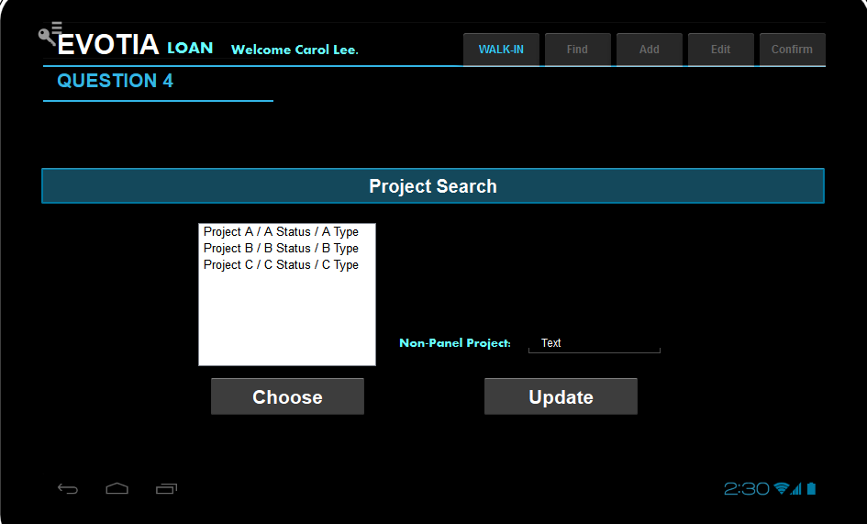

User either chooses from the list of projects which the firm is the panel lawyer or, enter the project name, and the project code is set as “I” which indicates there is no valid project code.

Proceed to Add Case.

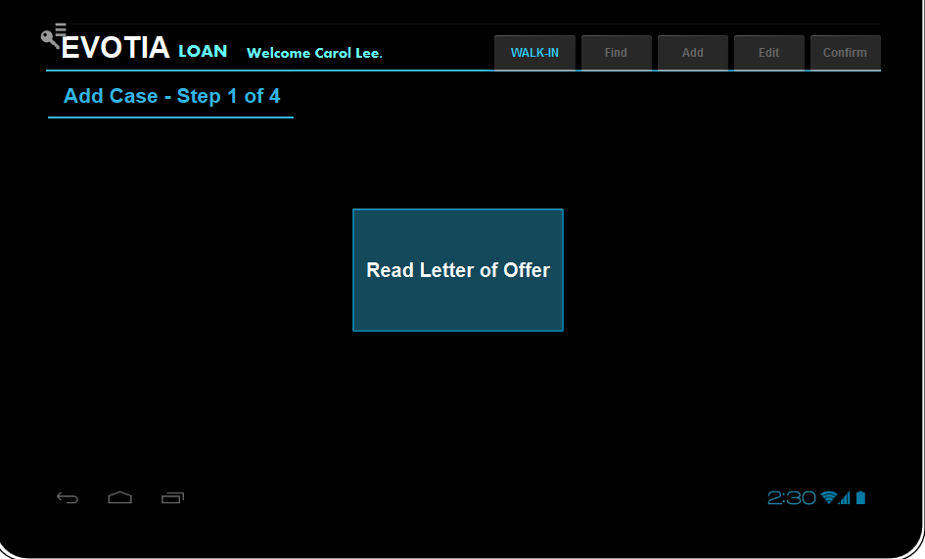

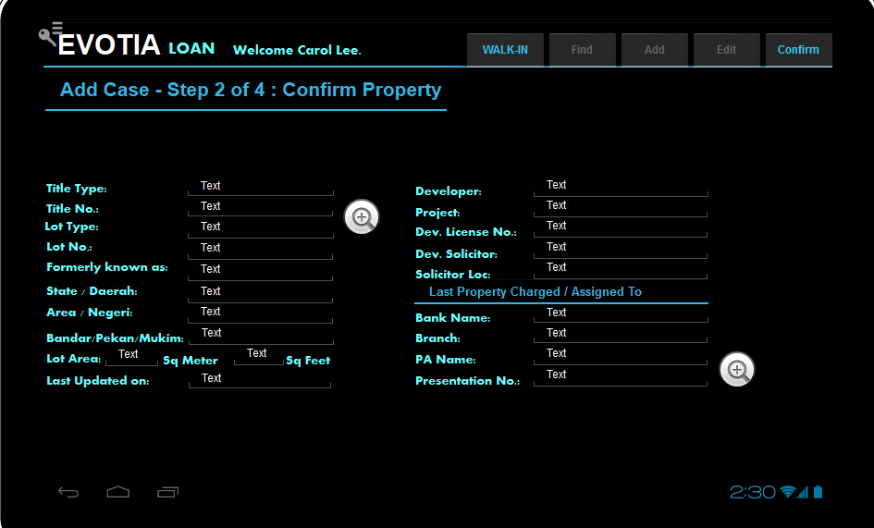

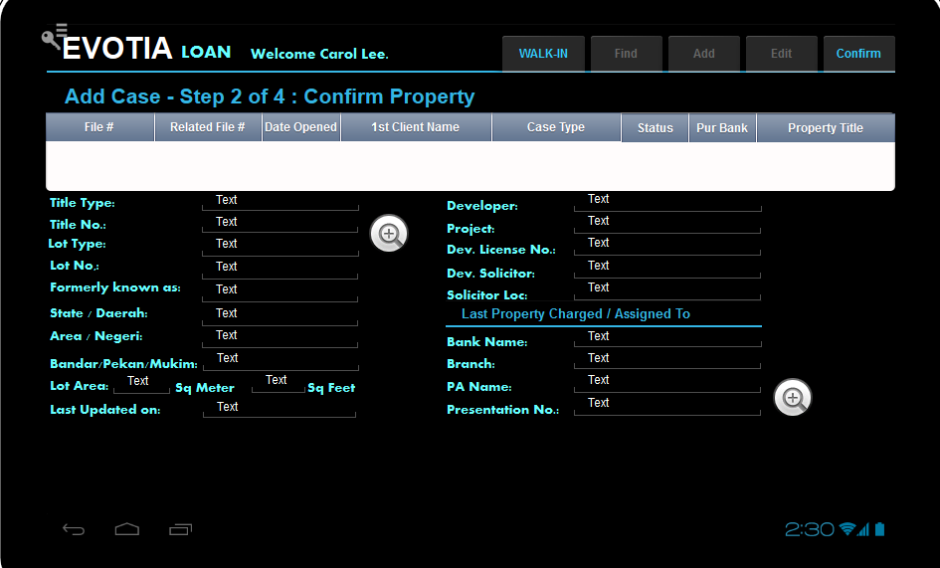

If a duplicated open loan case WITH SAME PROPERTY is found, do not allow user to proceed.

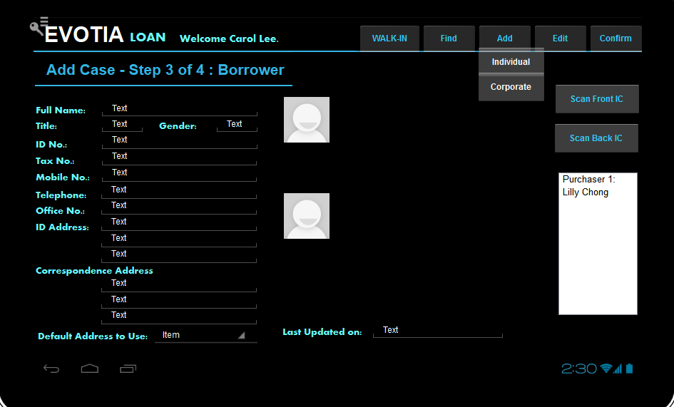

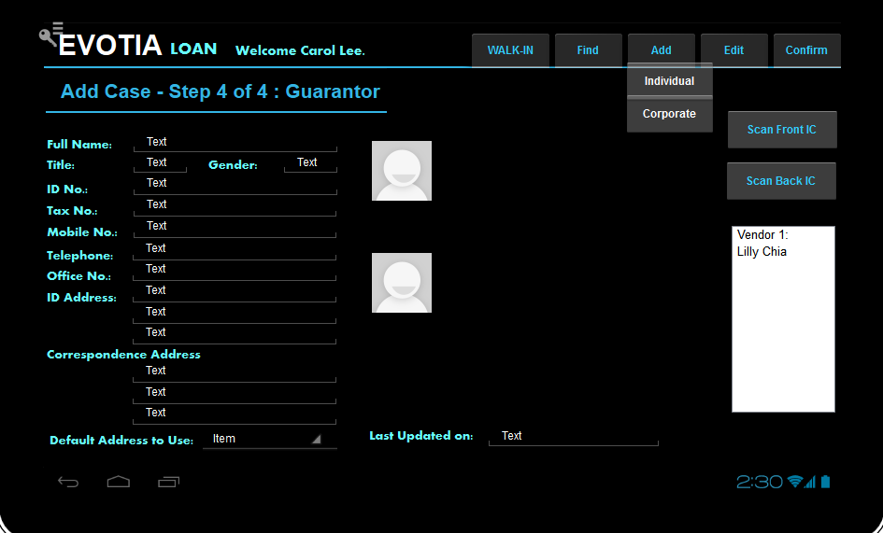

Guarantor is Optional. Allow to confirm case without any guarantor.

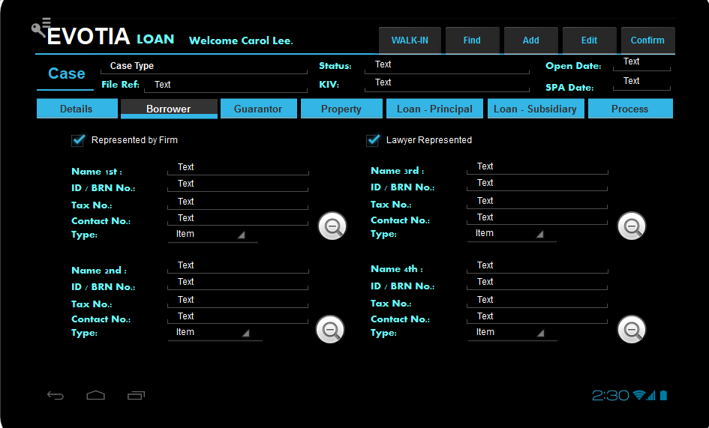

Case created will be similar to SPA. The only differences are:

1. Instead of Purchaser and Vendor, Borrower and Guarantor will be shown.
2. Process will be loan process.

# Acknowledgement

By signing this page, **Tia & Noordin** acknowledges that this document accurately represents the requirement of **Tia & Noordin** for the Sales & Purchase Module of the Mobile Application, and that this document is the base for the system implementation. The actual delivered product may differ from the mock up in this document.

|  |  |  |
| --- | --- | --- |
| **Definition** | **Name** | **Signature and Date** |
| Project Sponsor | Chris Tia |  |
| Project Manger | Carol Lee |  |